Bitbucket Webhook to Jenkins Add-on installation process

**Step 1:** Download Bitbucket Webhook to Jenkins Add-on from URL (https://marketplace.atlassian.com/plugins/com.nerdwin15.stash-stash-webhook-jenkins/server/overview) and below is the screen shot for the same :

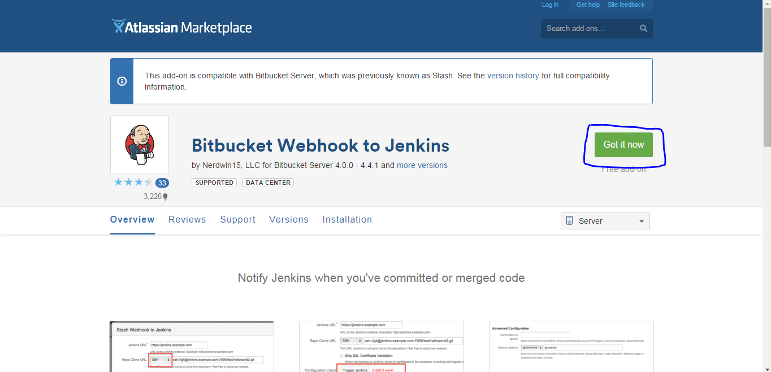

In the above screen shot we need to click on **Get it now** button to download the add-on.

**Step 2:**

Now in Bitbucket web interface we need to follow the below steps:

* Click on Administration icon(settings symbol) on home page of Bitbucket as shown below

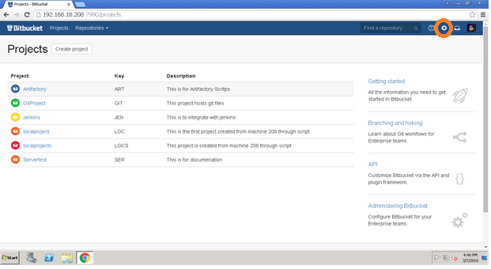

* Click on manage add-ons as shown below

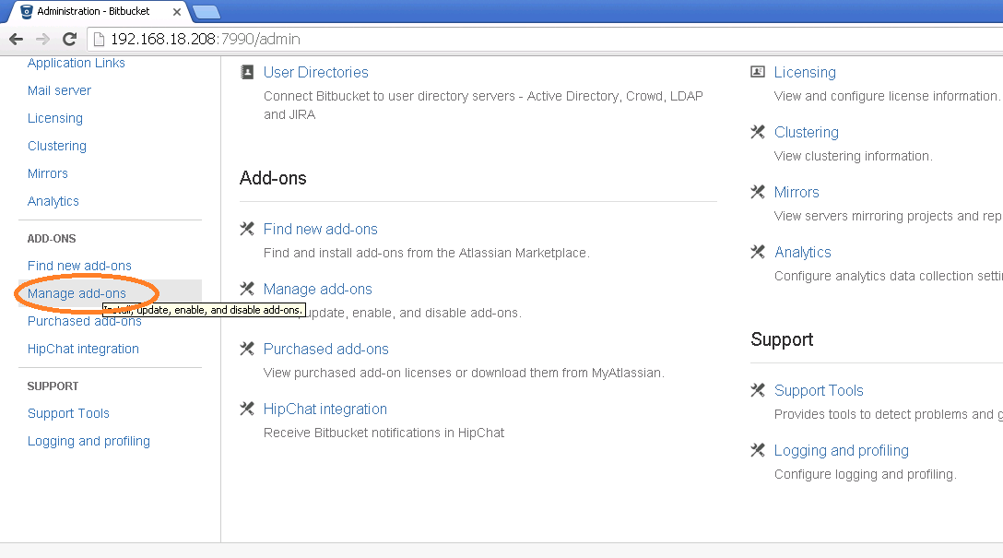

* In Manage add-ons page click on Upload add-on as shown below

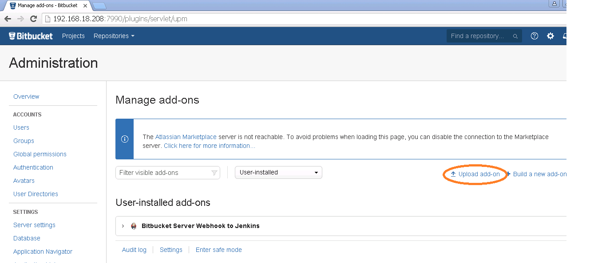

* Upload the downloaded add-on in the below screen and click on upload which will install the add-on in the bit bucket

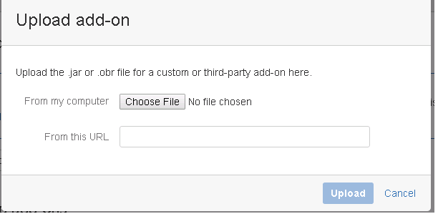

* Once the upload is successful we will be able to see the add-on in user installed add-ons as shown below

